Commonwealth of Virginia
Thomas A. Lisk, Chair  Andrew Kubincanek, Program Coordinator | 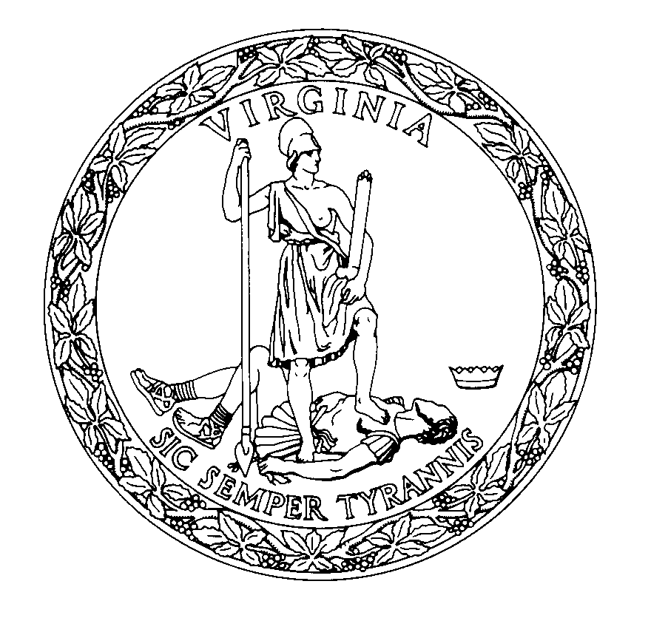 | General Assembly Building  201 N. 9th Street, Fourth Floor  Richmond, Virginia 23219  (Phone) 804-698-1810  akubincanek@dls.virginia.gov  http://codecommission.dls.virginia.gov/alac/alac.shtml
Administrative Law Advisory Committee

Agenda
Administrative Law Advisory Committee
December 18, 2025 – 1:00 PM
Virtual Meeting

I. Welcome and call to order

II. Hearing Officer Deskbook Revisions

III. Public Comment/Adjourn

